# Assignment -1

Build a smart home in Tinkercad with 2 sensors, an Led and buffer

|  |  |
| --- | --- |
| Assignment Date | 07 November 2022 |
| Team ID | PNT2022TMID44153 |
| Student Name | Masood |
| Student Roll Number | 724019104008 |
| Maximum Marks | 2 Marks |

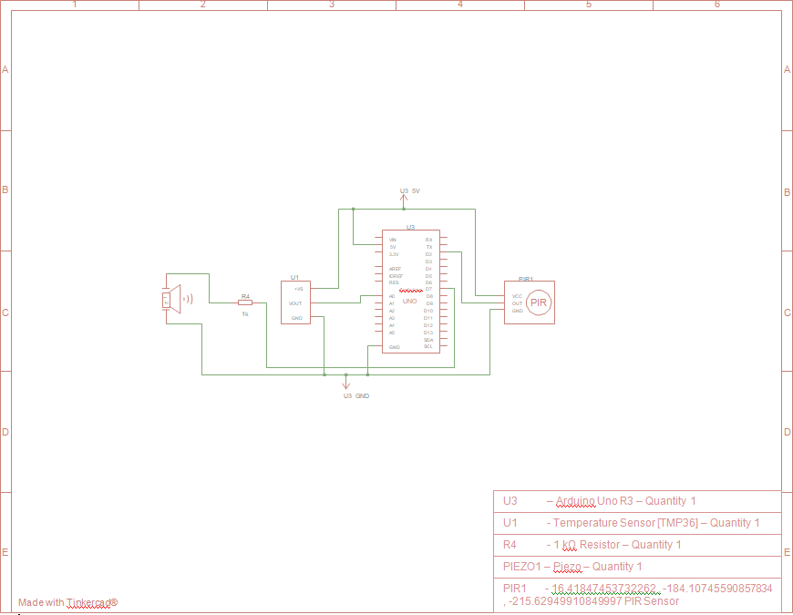

# Project Code:

int baselineTemp = 0; int celsius = 0;

int fahrenheit = 0; int pinSensor =2;

int pinBuzzer =7;

int pirSensor =0; void setup()

{

pinMode(A0, INPUT); Serial.begin(9600); pinMode(pinSensor, INPUT); pinMode(pinBuzzer, OUTPUT); pinMode(7, OUTPUT);

}

void loop()

{

baselineTemp = 60;

pirSensor = digitalRead(pinSensor);

celsius = map(((analogRead(A0) - 20) * 3.04), 0, 1023, -40, 125);

fahrenheit = ((celsius * 9) / 5 + 32); Serial.print(celsius);

Serial.print(" C, "); Serial.print(fahrenheit); Serial.println(" F");

if (celsius >= baselineTemp + 1)

{

tone(7, 220, 100);

delay(100);

}

if (pirSensor == HIGH)

{

tone(pinBuzzer, 1000, 500);

}

delay(100);

}

# Copy of Temperature , Motion Monitoring System with a Piezo Buzzer:

